Notes

I wonder if the initial page should be the flyer?
This would solve the issue that it’s not really AC Prides event.
Please change the script font in these areas
AC Pride Presents –
Run of Show
Our Sponsors
Last Year's Highlights
Get Involved

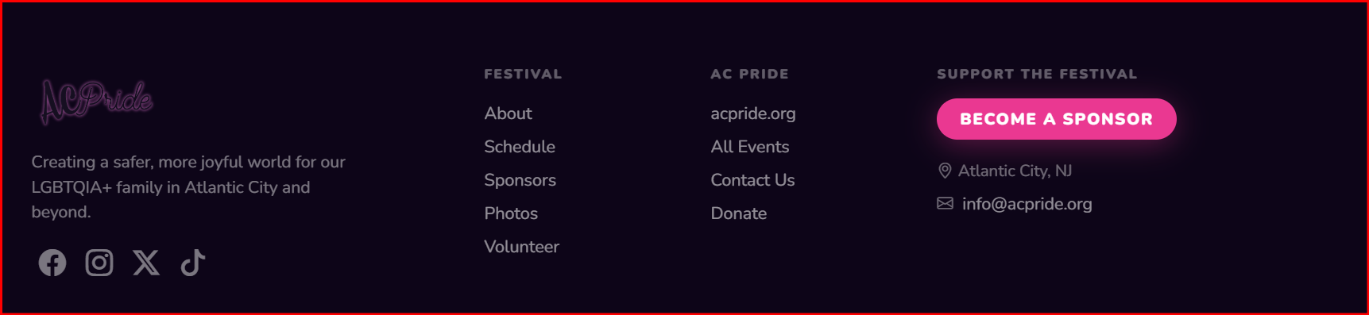

These links for Face Book, Instagram twitter and tik tock – should go to Great Pride
We don’t need this column

Support the festival – Sponsor the event, purchase a VIP ticket, Become a community or retail vendor

Where do the volunteer sign ups go?

